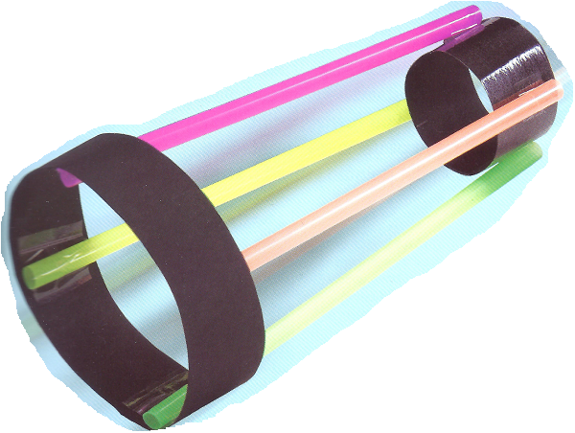
Glider Investigation

I In groups of 2-4, plan and conduct the Zappy Zoomer investigation.
Complete your write-up individually.

 |  | Mark Allocation | Mark
Title | - Title relevant and concise | 1
Aim and Hypothesis | - Aim is clear and concise  - Hypothesis relates independent and dependent variables | 2
Equipment and Procedure | - Appropriate equipment  - Procedure is detailed and specific  - Diagram is scientific, neat, labelled and appropriately sized  - Safety and ethics considered | 4
Variables | - Independent variable is identified  - Dependant variable is identified  - 3-5 controlled variables identified | 3
Results | - Table includes title which relates variables  - Columns relate to independent and dependent variables and include headings with units  - Repeat trials or replicates, averages | 3
Graph | - Graph title relates variables  - Graph type appropriate for data  - Axis correct orientation and labelled, including units  - Appropriate size and scale | 4
Discussion | - Results summarised and patterns identified  - Explanation of results using scientific knowledge  - Difficulties or sources of error identified  - Specific suggestions for improvement or further experimentation | 4
Conclusion | - Summary of findings  - Hypothesis supported or not. | 2
 | - Presentation, neatness and literacy | 2
Total
/25

Some things that you can consider:

Glider Investigation

- What did you notice about the flight of your aircraft? Does it repeat the pattern each time you fly it?

- Make one change to your aircraft to enable a change in flight, then fly your aircraft several times. How did the flight characteristics change with your wing change? What is the cause-effect relationship between your change and the flight change?

- Decide, as a class, what constitutes the "best" flight. Is it distance? Hang time? Loops? Once criteria is determined, embark on creating the best ring wing glider you can.

- Measure the diameter(s) of your ring-wing glider and measure the average linear distance it will fly (3 trials). Then create a second glider with a smaller or larger diameter(s) and measure the average linear distance it will fly. Does changing diameter influence linear distance flown?

- Investigate other variables by keeping an engineering log of your changes and quantify your changes by measuring them. Only change one variable at a time. Try different sizes and weights of paper, or vary the folds.

